This document details a process that can be used to upscale Deep Space 9. While the process is specific to the US release of Deep Space 9, it can be easily adapted to any upscale project coming from DVD.

This project is a guide that you can use to create your own project. It has been staged on github in hopes that as better scripts and processes are discovered, they can be submitted and shared with the community.

This is the second version of the project which uses a more generic script to obtain the pre-upscaled videos. While this script isn’t perfect, it Is very, very good.

## Obtain Project Source

Start by obtaining a copy of the project. If you’re not familiar with Github, the easiest way is to get it would be to download the zip file from the main project page. Just hit the [CODE] button and select *Download Zip*.

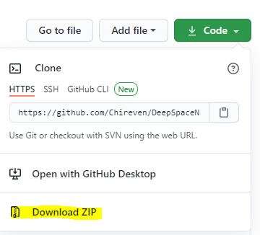

Extract this ZIP file to a drive with LOTS of space. While the project itself isn’t large, you’ll need lots of room for the various stages of the product.

## Obtain Source Video

In this step, we will collect:

* Video that we will use to upscale
* Audio for our final product
* Chapters
* Subtitles

Open DVD Decrypter. From the tools menu, choose Setting and select the IFO tab. Make sure that *Stream Information* and *Chapter Information – OGG* are selected and hit ok.

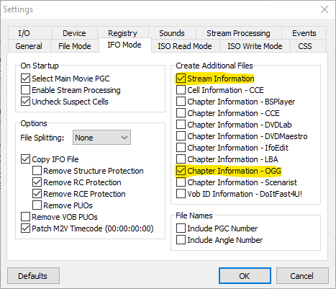

Back on the main DVD Decrypter window, select the PGC (Program Chain) that corresponds to the episode you are processing. Set the destination folder to the corresponding project folder.

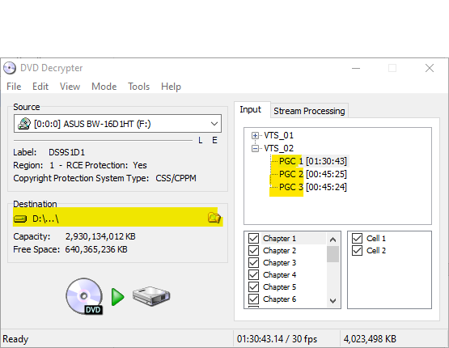

Select the Stream Processing tab and enable *Enable Stream Processing.* At minimum, select the Video stream, but it is recommended to select them all for use later.

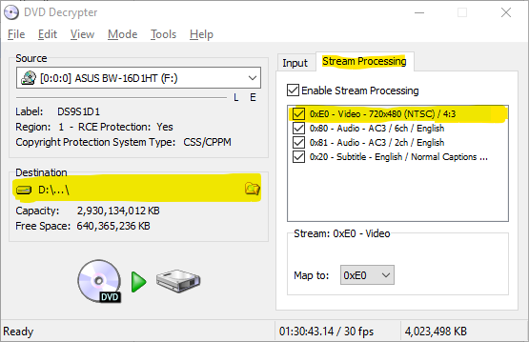

When DVD Decryptor has finished, rename the files it created to match the episode folder name, but keeping the current extension. For example, VTS2_02_01.VOB would become Deep Space Nine - S01E04 - A Man Alone.VOB ( if processing S01E04 ). At minimum, you should have a VOB and IFO file.

## Create D2V Project

Open DGIndex. From the Video menu, choose Field Operation and verify that Honor Pulldown Flags is selected.

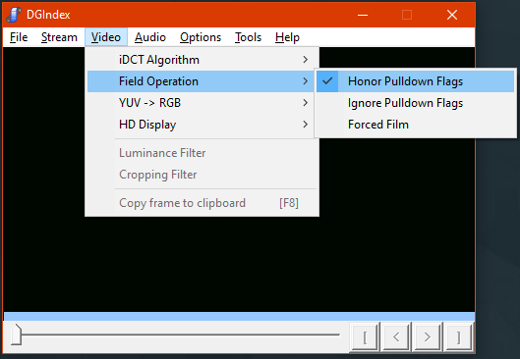

Open the File menu and choose open. Select the VOB file that you created from DVD Decrypter. You should see something similar to this – click OK.

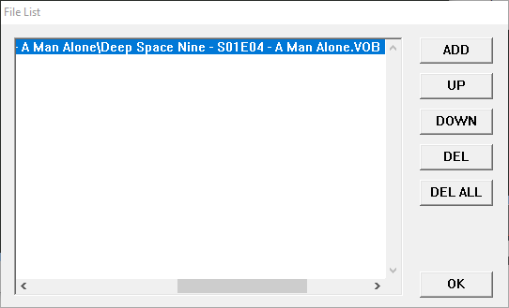

From the file menu, click Save Project. Save the file in the project folder for this episode. It should have the same name as the episode folder but with the D2G extension. When you see finish (as shown below) you can close DGIndex.

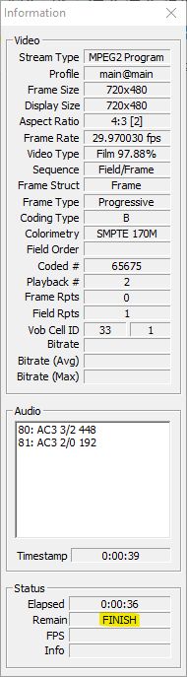

## Convert D2G/VOB to MKV

Requirements:

* a working 32bit Avisynth+ environment. Documentation will be added at a later date.
  + DGIndex Plugin
  + QTMGC Plugin
  + TFM/TDECIMATE Plugin
* 32bit version of ffmpeg

Open powershell and navigate to the project root. From this directory, execute the following script:

**.\encode-d2v.ps1 -ffmpegx86 <path to ffmpeg,exe> -inputPath <episode folder>**

### Example:

**.\encode-d2v.ps1 -ffmpegx86 D:\Video\Tools\ffmpeg\x86\ffmpeg.exe -inputPath '.\Season 01\Deep Space Nine - S01E04 - A Man Alone\'**

There are many other parameters you can use to manipulate the encoding of the file but they are not required if you are following this project. As the script runs, you should see the following:

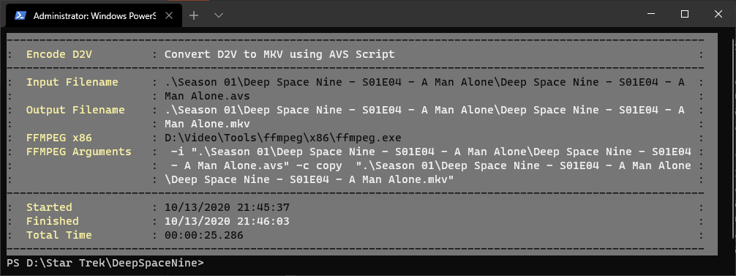

Another window will open to show you what FFMPEG is doing .

## Upscale the Video

Open Video Enhance AI and load the MKV file that you created in the previous step. You can choose whatever settings that you find to be the best, but the settings below will give you great results!

AI Mode : Gaia-CG

Preset : 4K UHD

Fromat : PNG (8bit lossless)

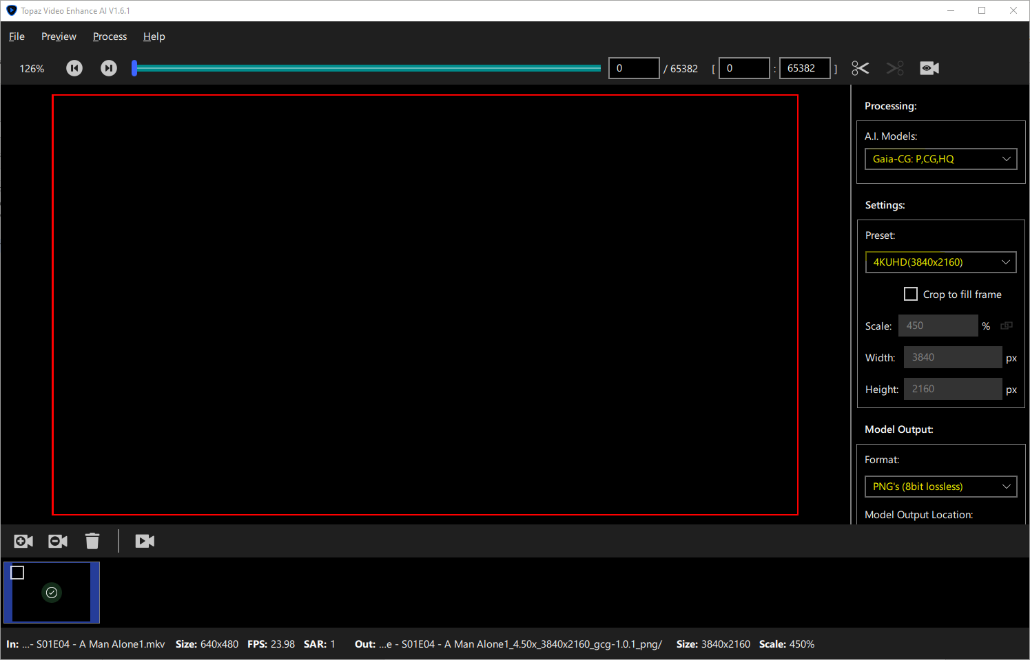

VEAI PRO TIP:

I did many upscales with the wrong settings because I assumed my settings were saved between each session of VEAI. That’s not the case. Once you have what you’ll be using for a while, I recommend setting it as the default. Just make the changes in the UI and then go to the Process Menu and choose

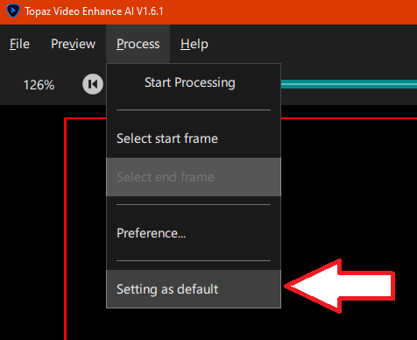

## Assemble the PNGs

At this point you should have a huge folder (300+ GB) of PNG files. To assemble them into a video, you can use the make-episode.ps1 powershell script.

Open Powershell and browse to the project root folder. Run the following command using parameters that match the episode you are working with:

**.\make-episode.ps1 <path to png files>**

### Example:

**.\make-episode.ps1 '.\Season 01\Deep Space Nine - S01E04 - A Man Alone\Deep Space Nine - S01E04 - A Man Alone_4.50x_3840x2160_gcg-1.0.1_png\'**

You should see something similar to the last script we ran – a status screen will show you some information and FFMPEG will pop up in the show you its progress as well.

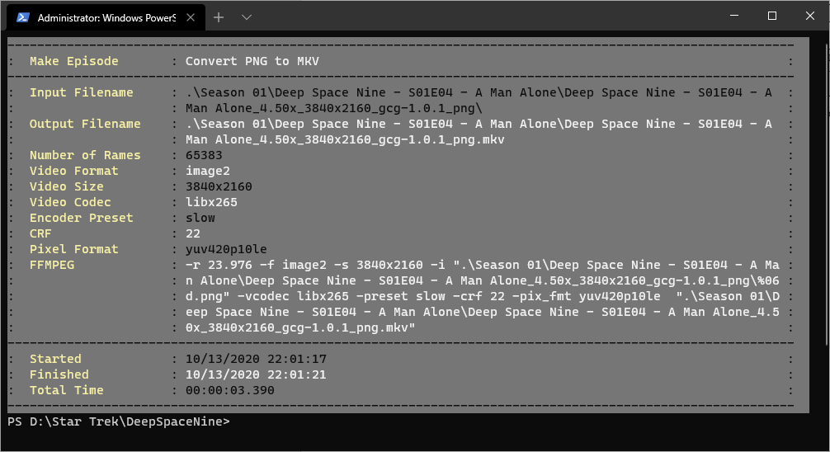

Once this is finished, you should have a 4K copy of the episode with no audio. We’ll add that in later.

## Assemble the Pieces

It’s now time to assemble all the pieces into a new container. We’ll use MKVToolNix GUI. Download and install this application, then open it up.

[Download](https://www.fosshub.com/MKVToolNix.html)

Once open, start to drag your project files (one at a time) into the upper window. After the first file, a box will pop up asking what you want to do with the file – make sure you choose the first option and hit OK.

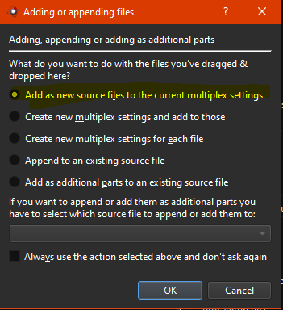

You can drag them in any order:

* VOB
* Upscaled MKV
* SRT (optional)

On the lower window, disable the MPEG-1/2 video by removing the check. While you’re here, select your Audio, Video, and Subtitle tracks (either one all at once, or one at a time if you have multiple languages). While your tracks are selected, set the language to the correct value on the left:

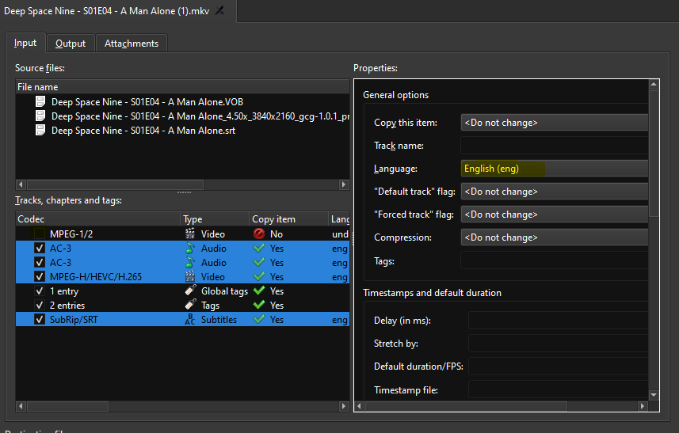

Switch to the Output Tab and load your chapter file. If you’re following this guide exactly, it should be called <episode name>_chapters.txt.

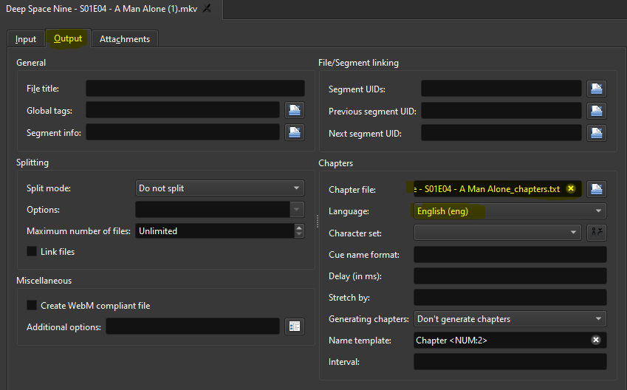

In the lower portion of the window, enter a destination filename and click *Start Multiplexing*.

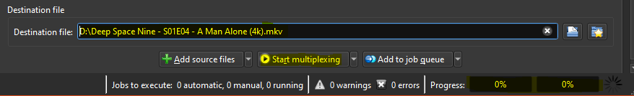

Watch the progress bars – it will look like this when its finished (don’t let the first progress bar stopping at 100% fool you!):



The process is now complete. You can now start your next episode.

Don’t forget – if you find any errors, problems, or better options – make sure to share the results on the project page!

<https://github.com/Chireven/DeepSpaceNine>